Charts and Graphical Analysis Worksheet
This worksheet demonstrates the use of graphical techniques, including percentage frequency bar charts and relative frequency histograms, to visualise and interpret both categorical and numerical datasets in Excel. The charts provide clear comparisons between groups and support the identification of key patterns within the data.

Academic Interpretations

Brand Preferences by Demographic Area (Exa 8.1D)
Percentage frequency bar charts were used to visualise the distribution of brand preferences across demographic areas. By expressing frequencies as percentages, the charts enable direct comparison between groups and clearly illustrate differences in relative preference for each brand.
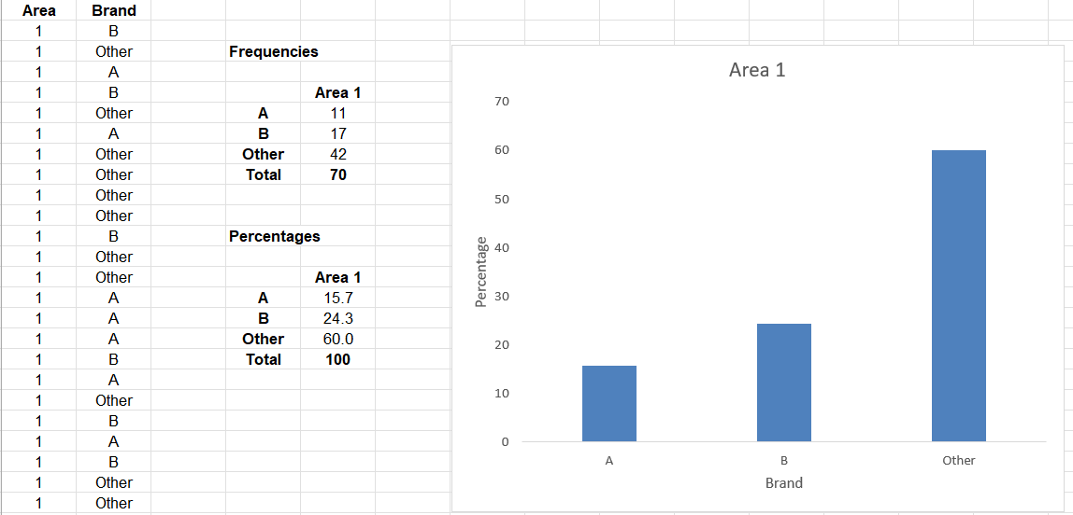

Comparison of Brand Preferences Between Areas (Exa 8.2D)
A percentage frequency clustered column chart was constructed to compare breakfast cereal brand preferences between Area 1 and Area 2. The chart displays the relative proportions of respondents selecting Brand A, Brand B, or other brands in each demographic area, enabling direct visual comparison between the two groups.
The graph shows that, while other brands remain the most popular choice in both areas, the percentages for Brands A and B are higher in Area 2 than in Area 1. Conversely, the proportion of respondents preferring other brands is lower in Area 2. This suggests a stronger preference for the named brands in Area 2 compared with Area 1
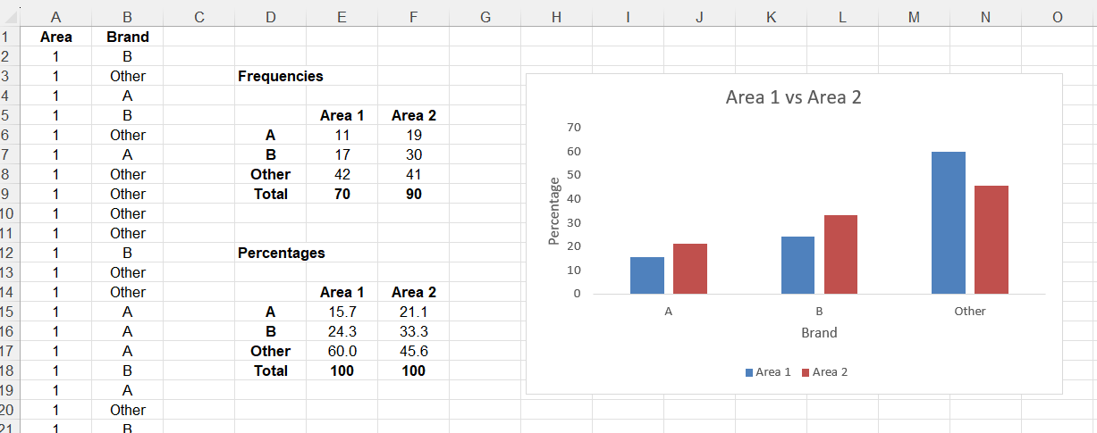

Diet A
The relative frequency histogram for Diet A is unimodal and approximately symmetric, with most observations concentrated in the central classes. This suggests that weight loss outcomes under Diet A are relatively consistent across individuals, with few extreme values.
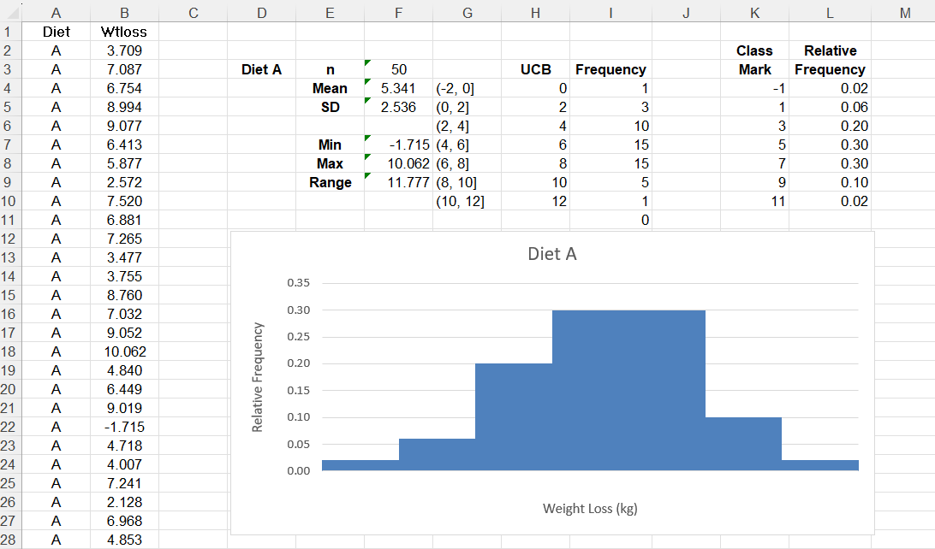

Diet B
The relative frequency histogram for Diet B is unimodal but exhibits a broader spread of weight-loss outcomes than that of Diet A. This indicates greater variability in individual responses to Diet B, with weight loss distributed more broadly across the class intervals.
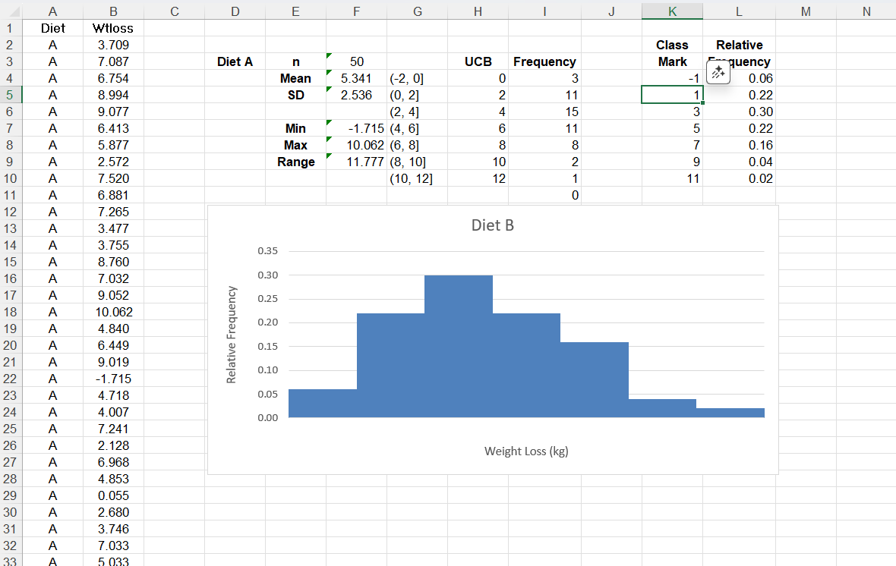

Comparison Interpretation — Diet A vs Diet B
Comparing the two histograms, Diet A shows a more concentrated, approximately symmetric distribution of weight loss, suggesting more consistent outcomes across individuals. In contrast, Diet B shows greater variability, indicating that individual responses to Diet B are less uniform.

Additional Reflection: Statistical Inference and Decision-Making
Alongside descriptive visualisation, this unit also reinforced the logic of statistical inference and hypothesis testing. The inference worksheet clarified the structured process of stating hypotheses, defining significance levels, computing test statistics, and making probabilistic decisions rather than claiming proof. A key insight was that statistical conclusions are always subject to uncertainty, with the risk of Type I and Type II errors forming an inherent part of analytical decision-making This learning complements the charts worksheet by highlighting the boundary between description and inference. While percentage frequency charts and histograms effectively summarise patterns in the data, inferential tests are required to assess whether observed differences are likely to reflect genuine population effects rather than sampling variation.
The emphasis on defining hypotheses a priori also reinforced the ethical importance of avoiding data-driven test selection, particularly when presenting results that may influence decisions or interpretations.
These visual comparisons are descriptive and exploratory and would need to be supported by inferential testing to determine whether observed differences are statistically significant.

